Online services – being able to see parts of your medical record, such as vaccinations/blood test results – even if you want to see these on the NHS app, you will need to follow these instructions
Once you have logged in to your online services via our website www.wellbridge.co.uk (choose online services from the right hand menu - your log in details will be contained in a letter provided to you when you signed up with GP online services), you will see this screen:
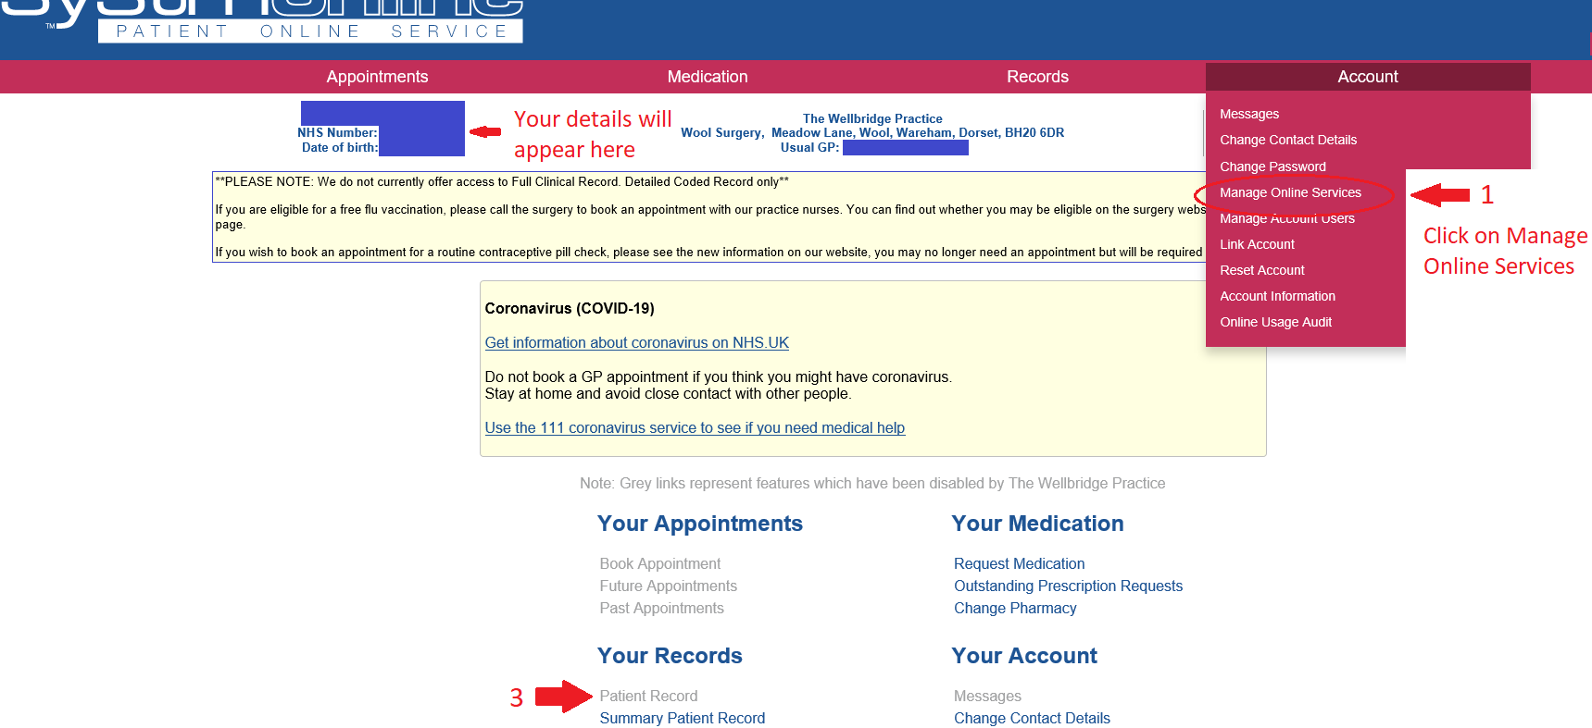

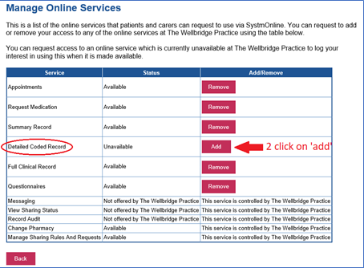
- Clicking on ‘Manage Online Services’ (above), will show what you have access to.
- You will need to choose to add the ‘Detailed Coded Record’ option (right), it will take up to 1 week for this to show on your desktop version of your medical record, and on the NHS/a third party app.
- Once this has been updated, to view these details (ie consultation history, including vaccinations and blood test results) on a desktop version of your online services, from the screen above choose ‘patient record’ or ‘records’ from the red horizontal options menu at the top of the screen. If you wish to see this information in the NHS app (or another third party app) you may need to log out of the app and back in for this information to appear.

